SAP 3 – Production
MGIS 4580 – Fall 2023 DELIVERABLE

Check Inventory Levels
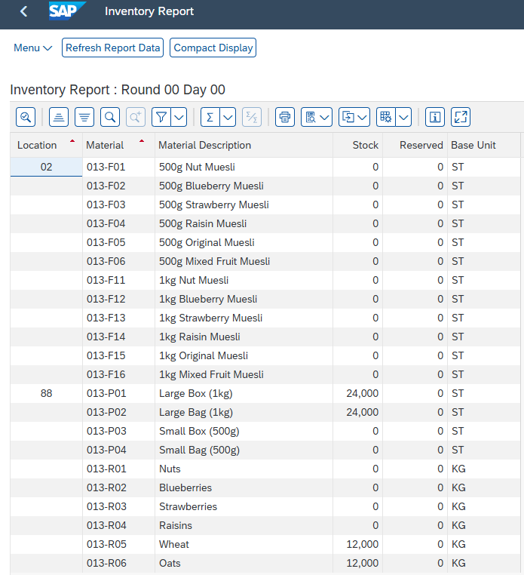

Confirm Production Completion
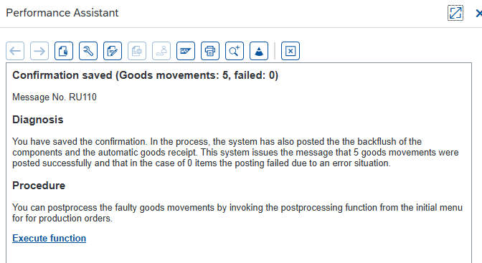

Check Inventory Levels
